**Log-probabilities for numerical stability**

Let’ say we have to calculate the p(y=1/w1,w2,w3...wd) = p(y=1)*p(w1/y =1)* p(w2/y =1)*…* p(wd/y =1) and d is large…let’s 100. The issue we will be each probability(rounded in screenshot) out value will be in between 0 and 1.

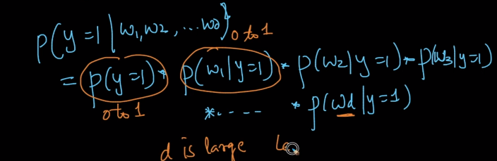  
For sure we will have decimal output. What python will do internally is they’ll round of the values which can cause result in-accurate.  
To avoid this we can apply log on both sides which will give out put in negative values..  
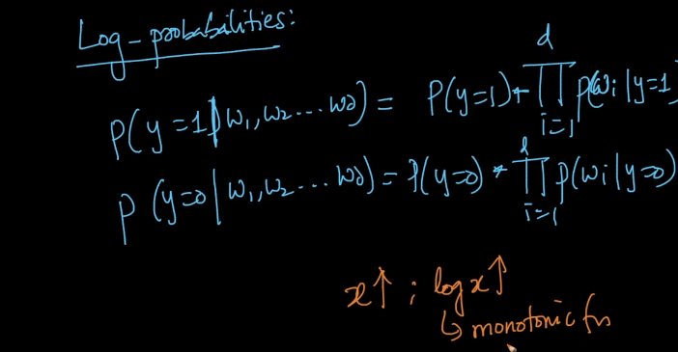  
see equation after applying log.   
if x increases, logs x also increases>

Log has some powerful techies here, it converts addition in to multiplication and Exponential into Multiplication.   
Below is the new formulae after applying log  
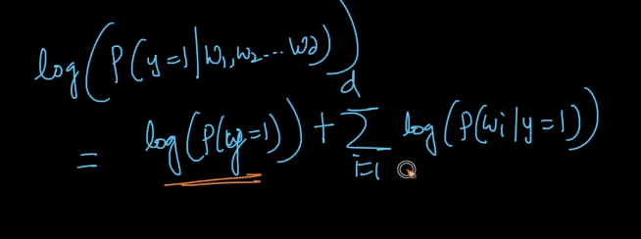  
🡪 Log(a+b) = log a + log b